**Business Contact Page**

*A thesis submitted in partial fulfillment of the requirement for the award of the degree*

*Of*

**Bachelor of Computer Application**

***in***

***Faculty of Computer Technology***



***Submitted by***

**Soniya Rani Das**

Roll no: ADTU/0/2024-27/BCAM/011

**Chow Hunkham Hailoung**

Roll no: ADTU/0/2024-27/BCAM/019

*Under the guidance of*

***Dr. Dulumani Das***

Faculty of Computer Technology

**Assam down town University**

**Guwahati-26, Assam**

Session: January-June, 2025

**CONTENTS**

|  |  |
| --- | --- |
|  |  |
| * *Certificate of Approval* | i |
| * *Certificate from Guide* | ii |
| * *Declaration* | iii |
| * *Acknowledgement* | iv |
| * *Abstract* | v |
| * *List of Figures* | vi |

**Chapter Page No**

|  |  |
| --- | --- |
| 1. **Introduction** |  |
| * 1. Overview of the Project | 1-2 |
| * 1. Motivation |  |
| * 1. Scope and Objective |  |
| * 1. Problem Definition |  |
| * 1. Proposed System |  |
|  |  |
| 1. **Project Analysis** |  |
| * 1. Project Requirement Analysis | 3-5 |
| * 1. Gantt Chart |  |
| * 1. Advantage & Disadvantage |  |
| * 1. Project Life Cycle   2. Project Feasibility |  |
| 1. **Project Design** |  |
| * 1. System Architecture | 6-7 |
| * 1. Sequence Diagram |  |
|  |  |
|  |  |
|  |  |
|  |  |
| 1. **Project Implementation** |  |
| * 1. Description of the Software Used | 8-11 |
| * 1. User Interface |  |
| 1. **Testing** |  |
| * 1. Types of Testing | 12-13 |
| * 1. Test Cases |  |
| 1. **Conclusion and Future Scope** |  |
| * 1. Conclusion | 14 |
| References | 14 |



***Faculty of Computer Technology***

***Assam down town University***

Gandhi Nagar, Panikhaiti, Guwahati- 781026, Assam

**CERTIFICATE OF APPROVAL**

This is to certify that the project report entitled ***“Business Contact Page”*** submitted by **Soniya Rani Das** bearing Roll No. ADTU/0/2024-27/BCAM/011 and **Chow Hunkham Hailoung** bearing Roll No. ADTU/0/2024-27/BCAM/019, are hereby accorded our approval as a study carried out and presented in a manner required for acceptance in partial fulfilment for the award of the degree of ***Bachelor of Computer Application*** under Assam down town University for approval does not necessary endorse or accept every statement made opinion expressed or conclusion drawn as recorded in the report. It only signifies the acceptance of the project report for a purpose which is submitted.

**Date:**  **Dr. Aniruddha Deka**

**Place: Guwahati** Dean (i/c), Faculty of Computer Technology

Assam down town University

Guwahati



***Faculty of Computer Technology***

***Assam down town University***

Gandhi Nagar, Panikhaiti, Guwahati- 781026, Assam

**CERTIFICATE FROM GUIDE**

This is to certify that the project report entitled ***“Business Contact Page”*** submitted by **Soniya Rani das** bearing Roll No. ADTU/0/2024-27/BCAM/011 and **Soniya Rani das** bearing Roll No. ADTU/0/2024-27/BCAM/019 towards the partial fulfilment of the requirements for the award of the degree of ***Bachelor of Computer Application*** under Assam down town University is a bonafide research work carried out by them under my supervision and guidance. This work has not been submitted previously for any other degree of this or any other University.

I recommend that the thesis may be placed before the examiners for consideration of award of the degree of this University.

|  |  |
| --- | --- |
| **Date:**  **Place: Guwahati** | **Dr. Dulumani Das**  Faculty of Computer Technology  Assam down town University  Guwahati |
|  |  |

**DECLARATION**

We, **Soniya Rani Das** bearing Roll No. ADTU/0/2024-27/BCAM/011 and **Chow Hunkham Hailoung** bearing Roll No. ADTU/0/2024-27/BCAM/019 hereby declare that the thesis entitled ***“Business Contact Page”*** is an original work carried out in the Department of Computer Technology, Assam down town University, Guwahati with exception of guidance and suggestions received from my supervisor, ***Dr. Dulumani Das****,* Department of Computer Technology, Assam down town University, Guwahati. The data and the findings discussed in the thesis are the outcome of our research work. This thesis is being submitted to Assam down town University for the degree of ***Bachelor of Computer Application”.***

**Soniya Rani Das Chow Hunkham Hailoung**

Enrolment: ADTU/0/2024-27/BCAM/011 Enrollment: ADTU/0/2024-27/BCAM/019

2nd Semester

BCA AI & DL

Faculty of Computer Technology

Assam down town University

Guwahati

**ACKNOWLEDGMENT**

We would like to extend our heartfelt appreciation to everyone who contributed to the successful completion of this project. Our sincere thanks go to our project team members for their dedication and collaboration throughout the project. Each member played a significant role in shaping the outcome. Special thanks to our supervisor, Dr. Dulumani Das, for her guidance and valuable feedback, which enriched our work. Lastly, we want to thank our friends for their patience and encouragement during this project. Their believe helped us to stay motivated and to persevere through difficult times.

**ABSTRACT**

This project implements a standalone, responsive "Contact Us" page for *KiaGeet Pvt. Ltd.*, integrating business communication functionality into a clean and minimalistic layout. The design follows modern web development practices with a focus on usability, accessibility, and performance.

Key features include a structured contact form with real-time client-side validation using JavaScript, ensuring users provide valid email addresses and 10-digit mobile numbers before submission. Business contact information, including address, phone number, and office hours, is clearly presented for easy access. Additionally, the integration of a Google Maps embed provides users with a visual reference to the company’s physical location in Guwahati, Assam.

Styling is handled through CSS for an aesthetically pleasing, mobile-friendly interface that adapts to various screen sizes. The page is also optimized with appropriate meta tags to support search engine visibility and fast loading. Overall, this project delivers a functional, accessible, and professional contact interface suitable for any business environment.

**List of Figures**

|  |  |
| --- | --- |
| **Sl no.** | **Name of the figure/chart** |
| **1** | **Gantt Chart** |
| **2** | **System Architecture** |
| **3** | **Data Flow Diagram** |
| **4** | **Sequence Diagram** |
| **5** | **Wireframes/Ui** |
|  |  |
|  |  |
|  |  |
|  |  |

**1. INTRODUCTION**

**1.1 Overview of the project**

The Business Contact Page project is designed to create a professional, user-friendly interface that allows customers, partners, and stakeholders to easily connect with the company. This page serves as a crucial touchpoint, enhancing communication, building trust, and supporting customer service efforts. The project focuses on integrating essential contact details, an interactive form, location mapping, and links to social media and support channels. By providing clear and accessible contact options, the goal is to improve user experience and encourage seamless engagement with the business.

**1.2 Motivation**

Effective communication is vital for building strong relationships with customers and stakeholders. Many businesses lose opportunities due to unclear or inaccessible contact information. The motivation behind this project is to create a streamlined and reliable contact page that not only reflects the company’s professionalism but also makes it easy for users to reach the right department or individual quickly. A well-designed contact page boosts credibility, enhances customer satisfaction, and supports business growth by fostering better engagement and trust.

**1.3 Scope and Objective**

The scope of this project includes the design and implementation of a professional and user-centric Business Contact Page that integrates essential contact details, an interactive inquiry form, location mapping, and links to relevant communication channels such as email, phone, social media, and customer support. The objective is to facilitate seamless and efficient communication between the organization and its external stakeholders by providing a centralized, accessible, and secure platform. This initiative aims to enhance user experience, improve response efficiency, and strengthen the organization’s credibility and engagement through a well-structured digital contact interface.

**1.4 Existing system**

The existing system for business contact primarily relies on static web pages or basic contact information listings, often lacking interactive features or clear navigation. In many cases, users are required to manually copy email addresses or phone numbers, leading to potential delays and communication errors. Additionally, there is limited integration with mapping services, social media platforms, or automated response systems, which can hinder user engagement and overall efficiency. The absence of a structured inquiry form or intelligent routing of messages may also result in misdirected queries and slower response times, thereby affecting customer satisfaction and the organization’s professional image.

**1.5 Problem Definition**

The current method of handling business inquiries through outdated or minimally functional contact pages presents several challenges. These include lack of user engagement, inefficient communication processes, limited accessibility across devices, and absence of features such as automated responses, structured inquiry forms, and integrated location or department-specific contact options. As a result, users often experience confusion or delays in reaching the appropriate personnel, which can lead to missed opportunities, decreased customer satisfaction, and a weakened organizational image. Therefore, there is a clear need for a modern, efficient, and user-friendly contact page that addresses these limitations and enhances communication effectiveness.

**1.6 Proposed System**

The proposed system aims to develop a modern, responsive, and fully integrated Business Contact Page that addresses the limitations of the existing setup. This system will feature a structured and user-friendly contact form, enabling visitors to submit inquiries directly through the website with clear categorization to ensure efficient routing. It will include essential contact information, interactive location mapping, and seamless links to social media and customer support platforms. Additionally, the system will support mobile responsiveness, accessibility standards, and potential integration with automated acknowledgment or CRM systems. The overall goal is to improve user experience, facilitate prompt and accurate communication, and reinforce the organization’s professional presence.

**2. PROJECT ANALYSIS**

**2.1 Project Requirement Analysis**

The KiaGeet Contact Page project requires a well-structured blend of functional and non-functional components to ensure an effective communication interface. Functionally, the system must include a user-friendly contact form with fields for name, email, mobile number, and message, supported by client-side validation and confirmation alerts. It should also present key business information such as address, phone number, and operating hours, alongside an embedded Google Map for location reference. Non-functional requirements include responsive design for compatibility across devices, fast loading performance, input security to prevent invalid or harmful data, and high usability through intuitive layout and accessibility. Additionally, the codebase must be maintainable and scalable to allow for future integration with backend systems such as email servers or customer relationship management (CRM) tools.

**2.2 Gantt Chart**

|  |  |  |  |  |  |
| --- | --- | --- | --- | --- | --- |
|  | **January** | **February** | **March** | **April** | **May** |
| Information Gathering |  |  |  |  |  |
| Analysis |  |  |  |  |  |
| Coding |  |  |  |  |  |
| Testing |  |  |  |  |  |
| Analysis |  |  |  |  |  |

**2.3 Advantage and Disadvantage**

**Advantage:**

1. **Enhanced User Experience:** Provides an intuitive, easy-to-navigate interface that enables users to quickly find contact details and submit inquiries.

2. **Improved Communication Efficiency:** Structured forms and clear information ensure messages reach the appropriate department, reducing delays and errors.

3. **Professional Online Presence:** Incorporates responsive design and interactive elements like maps, enhancing the company’s credibility and accessibility.

**Disadvantages:**

1.**Limited Offline Accessibility:** The system relies on internet connectivity, making it inaccessible in areas with poor or no network coverage.

2. **Maintenance Requirement:** The page requires regular updates and security checks to keep information accurate and prevent vulnerabilities.

3. **Potential for Spam:** Without advanced backend filtering, contact forms may be susceptible to spam or malicious submissions.

**2.4 Project Lifecycle**

The project lifecycle involves several key phases from initiation to closure.i.e,

1.**Requirement Gathering:** Collect detailed needs and expectations from stakeholders for the contact page features.

2.**Planning:** Develop a project roadmap including timelines, resources, and technologies to be used.

3.**Design:** Create the visual and structural design focusing on usability, branding, and responsiveness.

4.**Development:** Code the contact form, embed maps, and implement validation and interactive elements.

5.**Testing:** Verify that the page works correctly on various devices and browsers, checking usability and security.

6. **Deployment:** Launch the completed contact page on the live website with proper configuration.

7. **Maintenance:** Monitor performance, fix issues, update content, and enhance features as needed over time.

**2.5 Project feasibility**

It typically involves evaluating various aspects to determine whether the project is feasible and worth pursuing. Here are the key components of a project feasibility study for this project:

**1.Technical Feasibility:** The project uses widely supported web technologies (HTML, CSS, JavaScript) and Google Maps integration, making development straightforward and manageable with existing skills and tools.

2. **Economic Feasibility:** The project requires minimal investment, mostly involving design and development time, with no expensive hardware or software, ensuring cost-effectiveness for the business.

3. **Operational Feasibility:** The contact page will be easy to use and maintain, fitting well within the company’s current operational processes and enhancing communication without major workflow changes.

4. **Schedule Feasibility:** Given the project’s defined scope and available resources, the contact page can be completed and deployed within a reasonable timeline, avoiding delays.

5. **Legal Feasibility:** The project complies with standard web regulations and privacy policies, ensuring that data collection and display of business information adhere to legal requirements.

6. **Market Feasibility:** A clear and accessible contact page improves customer engagement and trust, positively impacting the company’s reputation and competitive position in the market.

**3. PROJECT DESIGN**

**3.1 System Architecture**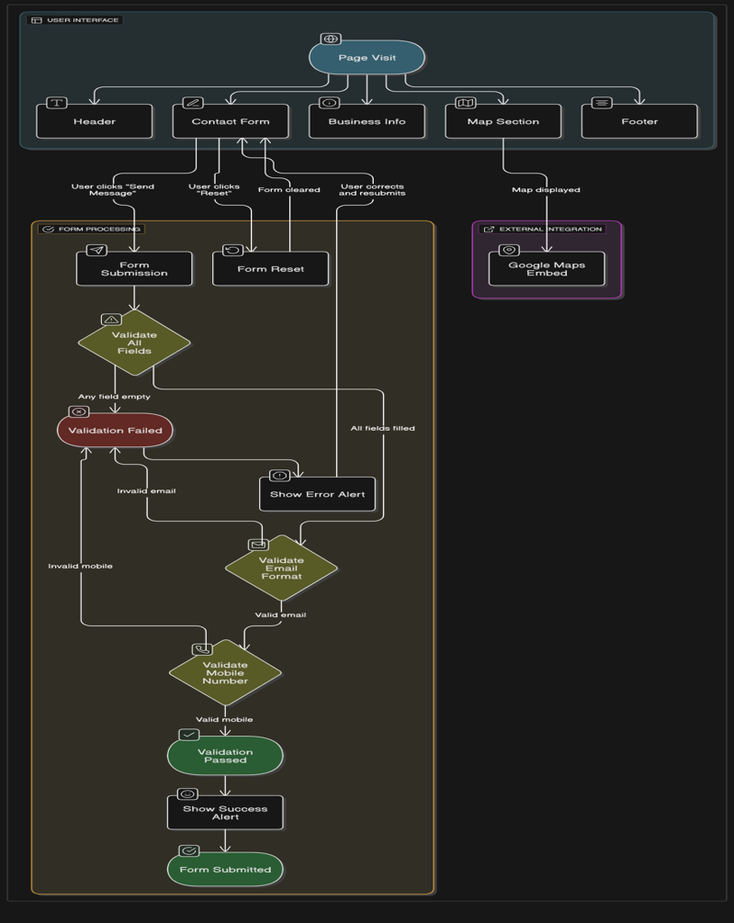

**3.2 Sequence Diagram**

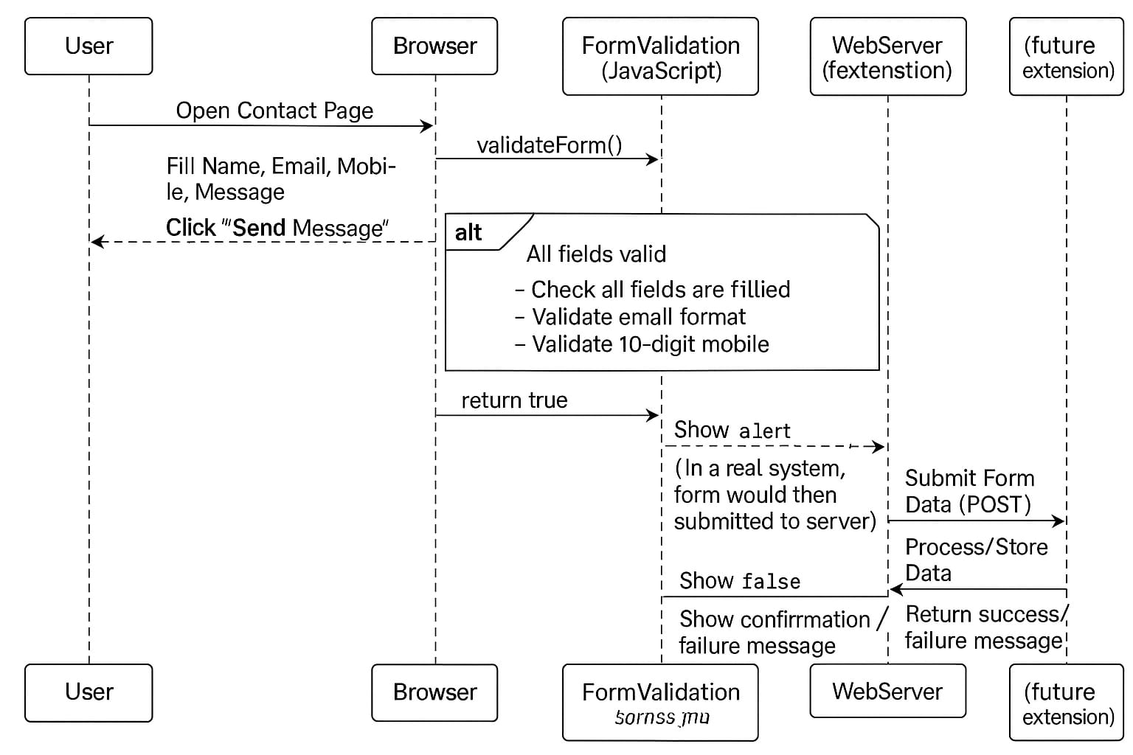

**4. PROJECT IMPLEMENTATION**

**4.1 Description of the software used**

1. **HTML (HyperText Markup Language)**

* Used to structure the content of the contact page including forms, headings, and business information.
* Provides semantic elements that improve accessibility and SEO.
* Ensures compatibility across all modern web browsers.

2. **CSS (Cascading Style Sheets)**

* Responsible for styling the page, including layout, colors, fonts, and responsiveness.
* Uses gradients, shadows, and flexible box model (flexbox) to create a modern and visually appealing design.
* Supports responsive design to make the page accessible on desktops, tablets, and smartphones.

3. **JavaScript**

* Implements client-side validation to ensure form inputs meet required formats before submission.
* Provides interactive feedback such as alerts on successful submission or error messages.
* Enhances user experience by preventing page reloads on form errors.

4. **Google Maps Embed API**

* Integrates an interactive map showing the business location directly on the contact page.
* Supports responsiveness and accessibility with ARIA labels.
* Requires no backend coding, making it lightweight and easy to implement.

5. **Web Browsers**

* Testing and usage are optimized for major browsers like Chrome, Firefox, Edge, and Safari.
* Cross-browser compatibility ensures consistent user experience.
* Developer tools in browsers assist in debugging and performance tuning during implementation.

6. **Code Editors and Version Control**

* Editors like Visual Studio Code or Sublime Text provide syntax highlighting and code completion.
* Version control systems (e.g., Git) help manage code changes and collaboration.
* Facilitate efficient development workflow and easier maintenance

**4.2 Wireframes/ Ui**

**Content Page**

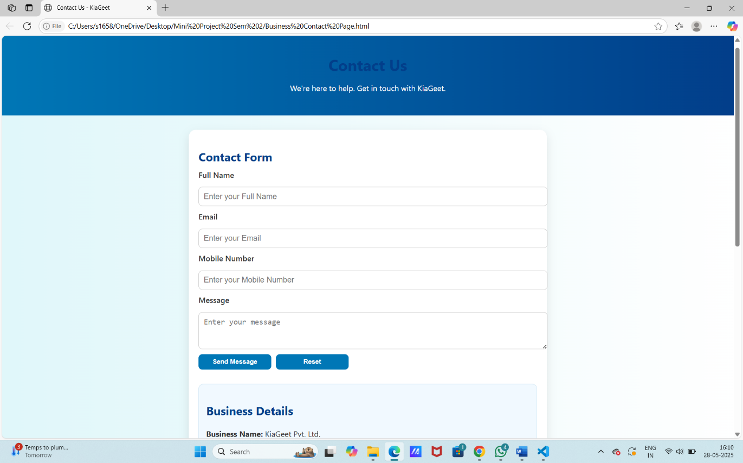

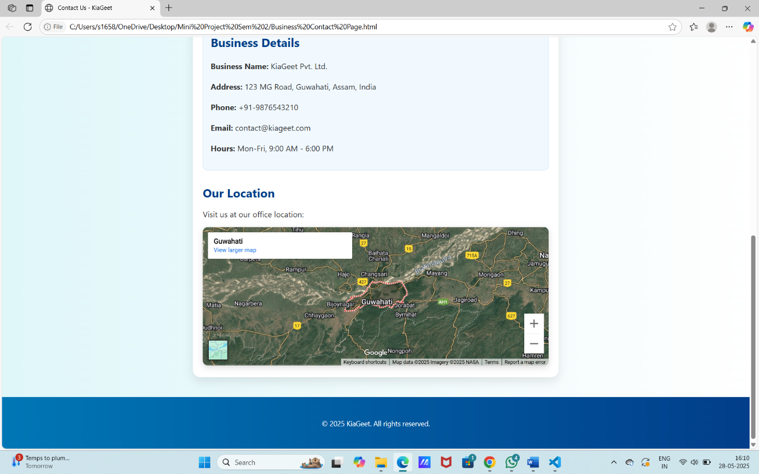

**Entering Less than 10 Digits in Mobile Number**

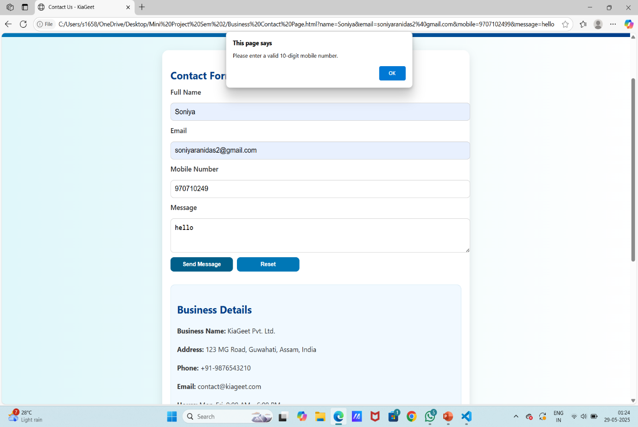

**Entering Wrong Email Format**

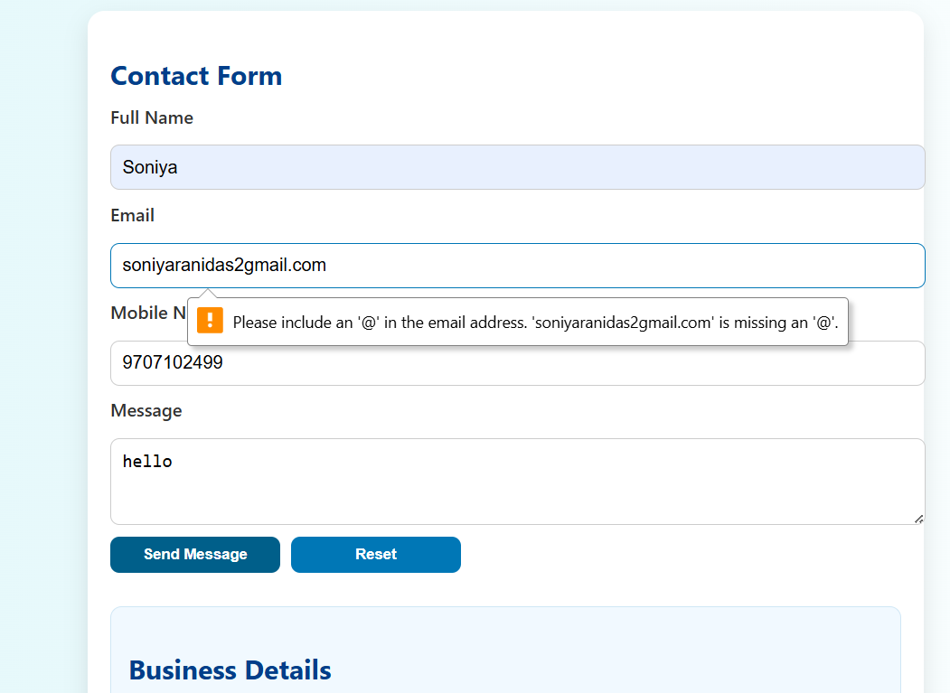

**Entering Details Correctly**

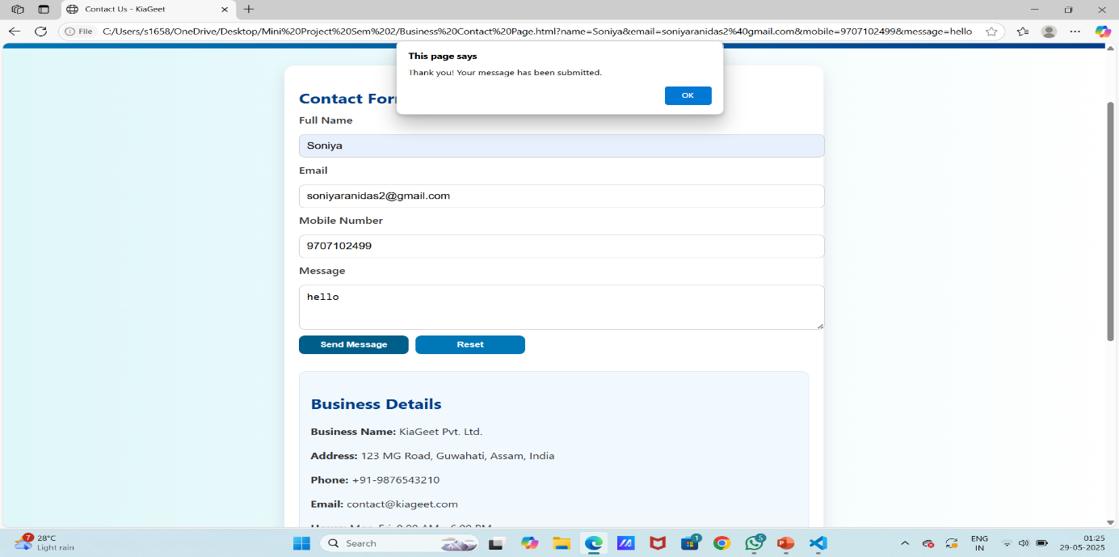

**5. Testing / Result Analysis**

**5.1 Types of Testing**

Some common types of testing to ensure its reliability, functionality, security and performance are:

1. **Functional Testing**

* Form Validation: Ensures all form fields accept valid inputs and prompt errors for invalid or missing data.
* Submission Handling: Verifies that the form submits correctly and provides user feedback upon success or failure.

2. **Usability Testing**

* User Interface: Checks if the page layout is intuitive, accessible, and easy to navigate for users of all skill levels.
* Responsiveness: Tests that the page adapts smoothly across different screen sizes and devices.

3. **Compatibility Testing**

* Browser Compatibility: Confirms consistent appearance and behaviour on browsers like Chrome, Firefox, Safari, and Edge.
* Device Compatibility: Ensures proper functionality on desktops, tablets, and mobile phones.

4. **Performance Testing**

* Load Time: Measures how quickly the page loads under typical and peak usage conditions.
* Resource Efficiency: Evaluates the impact on browser resources to avoid lag or crashes during user interaction.

**5.2 Test Cases**

1. **Form Field Validation**

* Check that all required fields (name, email, mobile, message) cannot be submitted empty.
* Validate the email field accepts only properly formatted email addresses.

2. **Mobile Number Validation**

* Ensure the mobile number accepts only numeric input with exactly 10 digits.
* Reject inputs containing letters, special characters, or incorrect length.

3. **Form Submission Feedback**

* Verify that submitting the form with valid inputs shows a success alert message.
* Confirm that invalid inputs prevent submission and display relevant error alerts.

4. **Form Reset Functionality**

* Test that clicking the reset button clears all form fields instantly.
* Ensure the form can be reused correctly after resetting.

5. **Responsive Layout**

* Check that the page layout adapts properly on different screen sizes (mobile, tablet, desktop).
* Verify that all form elements and buttons remain usable on smaller devices.

6. **Google Maps Integration**

* Confirm the map loads correctly showing the business location without errors.
* Test map interactivity (zoom, pan) works smoothly on all devices.

**6.1 Conclusion**

The KiaGeet Contact Page project successfully delivers a user-friendly and responsive platform that facilitates seamless communication between the business and its customers. By integrating a well-validated contact form, clear business information, and an interactive location map, the page enhances user engagement and accessibility. The implementation of modern web technologies ensures cross-device compatibility, fast performance, and ease of maintenance. Overall, this project strengthens KiaGeet’s online presence, improves customer support efficiency, and lays a solid foundation for future enhancements.

**6.2 References:**

<https://www.w3schools.com/html/html_forms.asp>

<https://developer.mozilla.org/en-US/docs/Learn_web_development/Extensions/Forms>

<https://developers.google.com/maps/documentation/embed/start>

<https://www.w3schools.com/js/js_validation.asp>